Model Answer IELTS Academic Writing Task 1
The diagram below show how houses can be protected in areas which are prone to flooding.
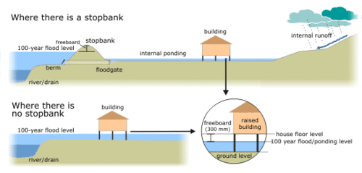

(183 Words, 10 Sentences, 4 Paragraphs, Band 9)
The diagrams compare two different methods of defence for homes which are at risk of being flooded.
The key difference between the diagrams is that they show flood protection with and without a stopbank. In either case, the at-risk home is raised on stilts above ground level.
The first diagram shows how a stopbank acts as a flood barrier to stop river water from flooding homes. The stopbank is a small mound of land next to the river that is higher than the 100-year flood level, and prevents the river from bursting its banks. Nearby houses can be built on stilts to prevent flooding from rainwater, and a floodgate beneath the stopbank can be opened to allow this "ponding"to drain off into the river.
When there is no stopbank, as shown in the second diagram, there will be nothing to stop the river from flooding. In this case, the solution is to put buildings on stilts. The height of the stilts is measured so that the floor of the house is 300mm above the 100-year flood level. This measurement is called the "freeboard".
(Source: IELTS-Simon, ex-IELTS examiner, NB: Follow the above band 9 writing structure for getting good band score in IELTS Exam.)

